U5 prevalence over time
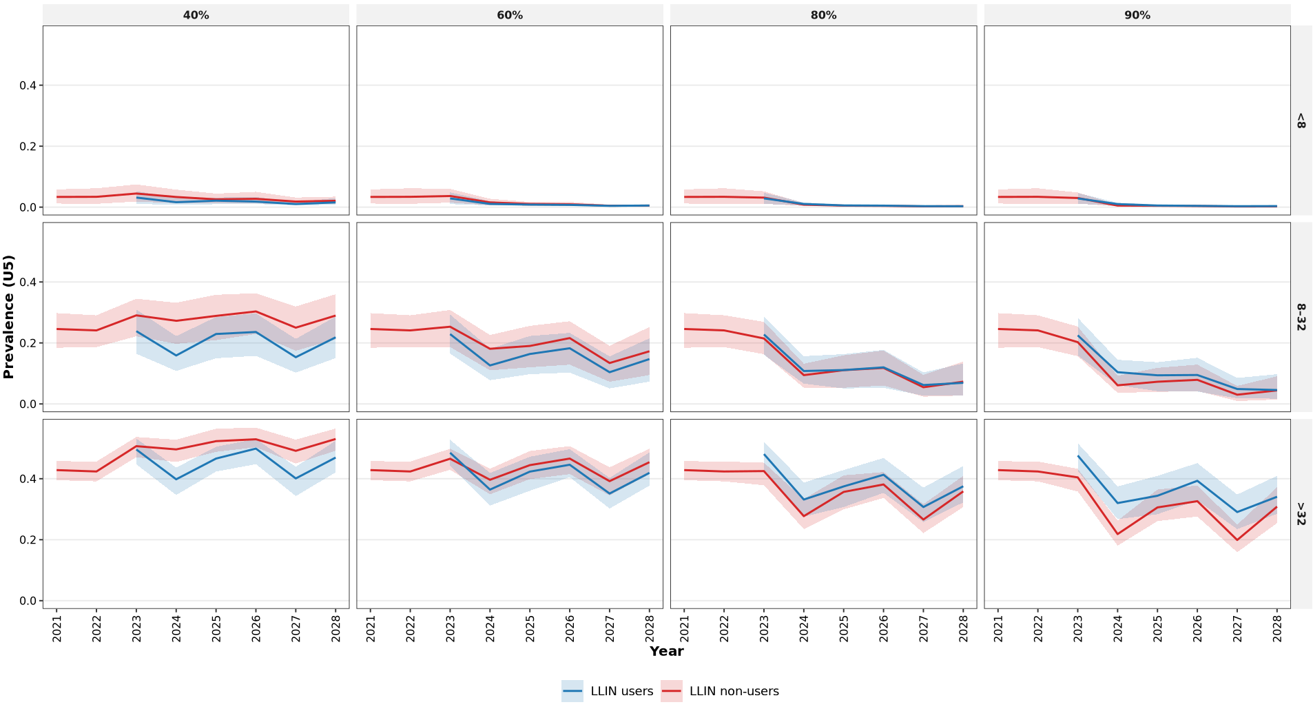
0-10
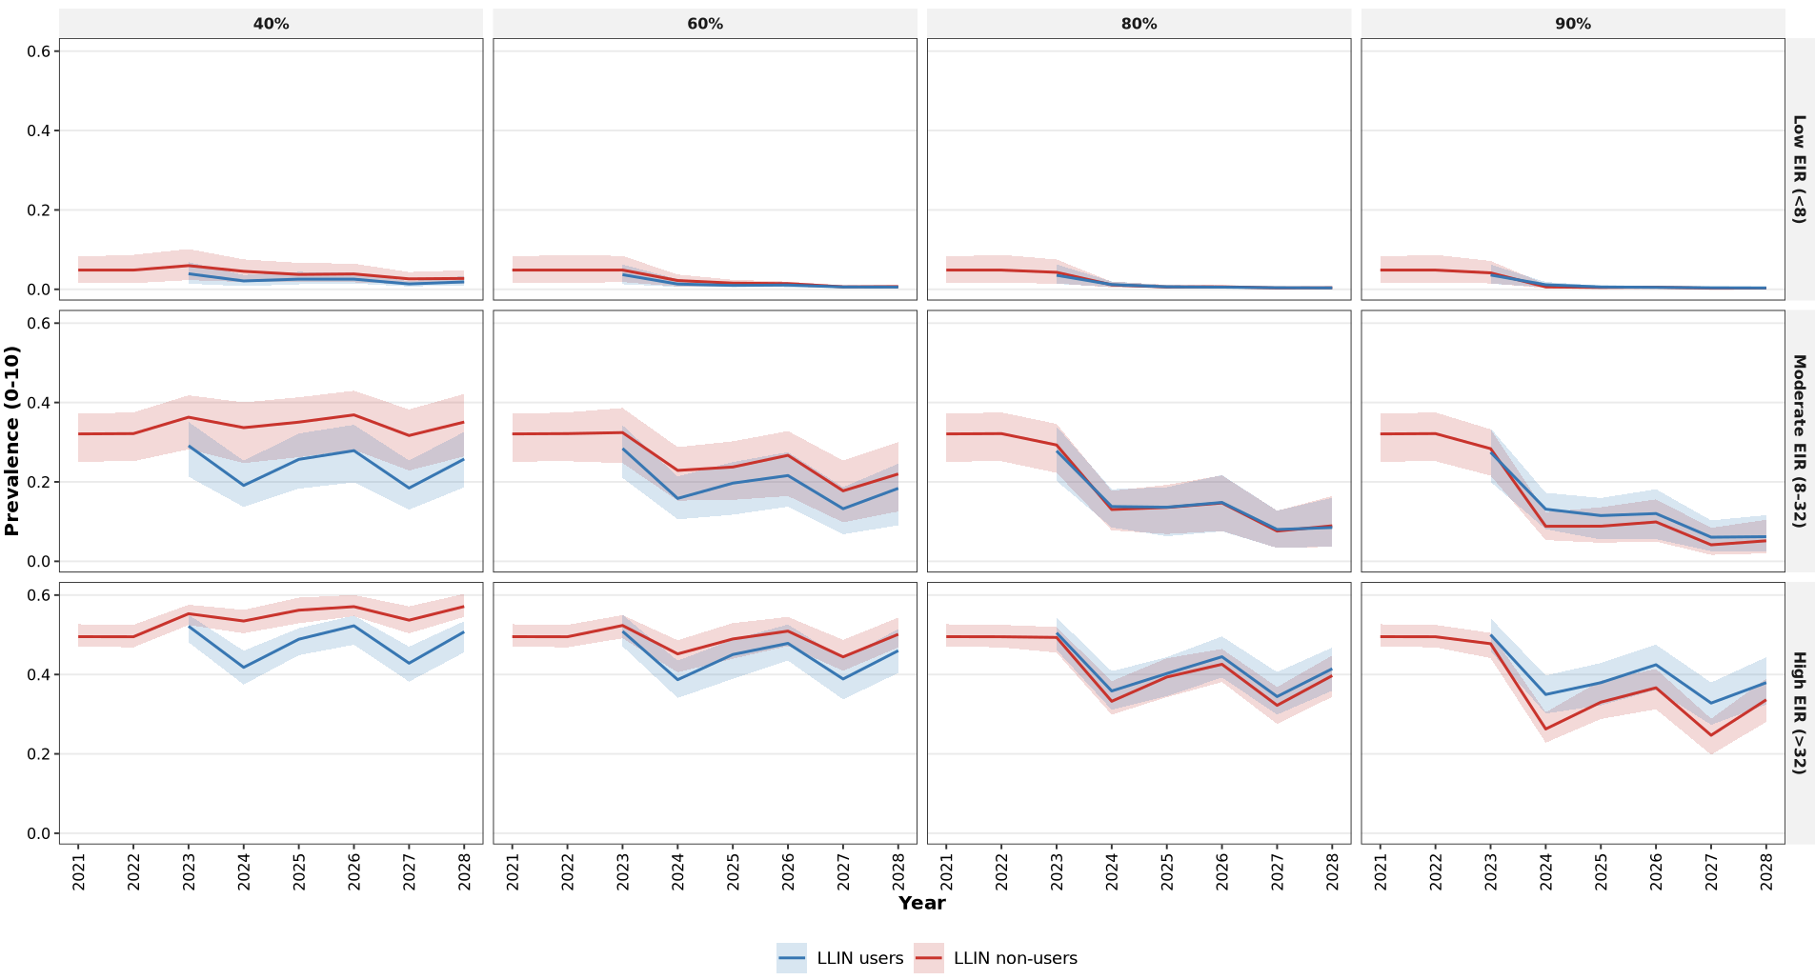

All ages
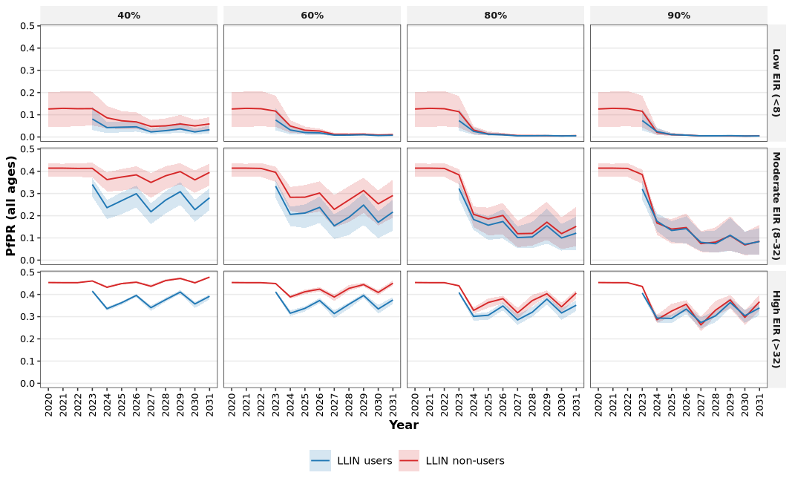

Coverage levels associated with the greatest loss of indirect protection
The magnitude of additional cases among non-users following reductions in LLIN coverage varied non-linearly across coverage levels, revealing distinct points of maximum sensitivity. In low transmission settings, the largest increases in non-user cases were observed when coverage was reduced from lower baseline levels, indicating that early gains in community protection are particularly fragile. In moderate transmission settings, losses were substantial across intermediate coverage reductions, suggesting that indirect protection is most sensitive within the mid-coverage range. In high transmission settings, additional cases increased more gradually across coverage reductions, reflecting weaker but more uniformly distributed indirect effects.

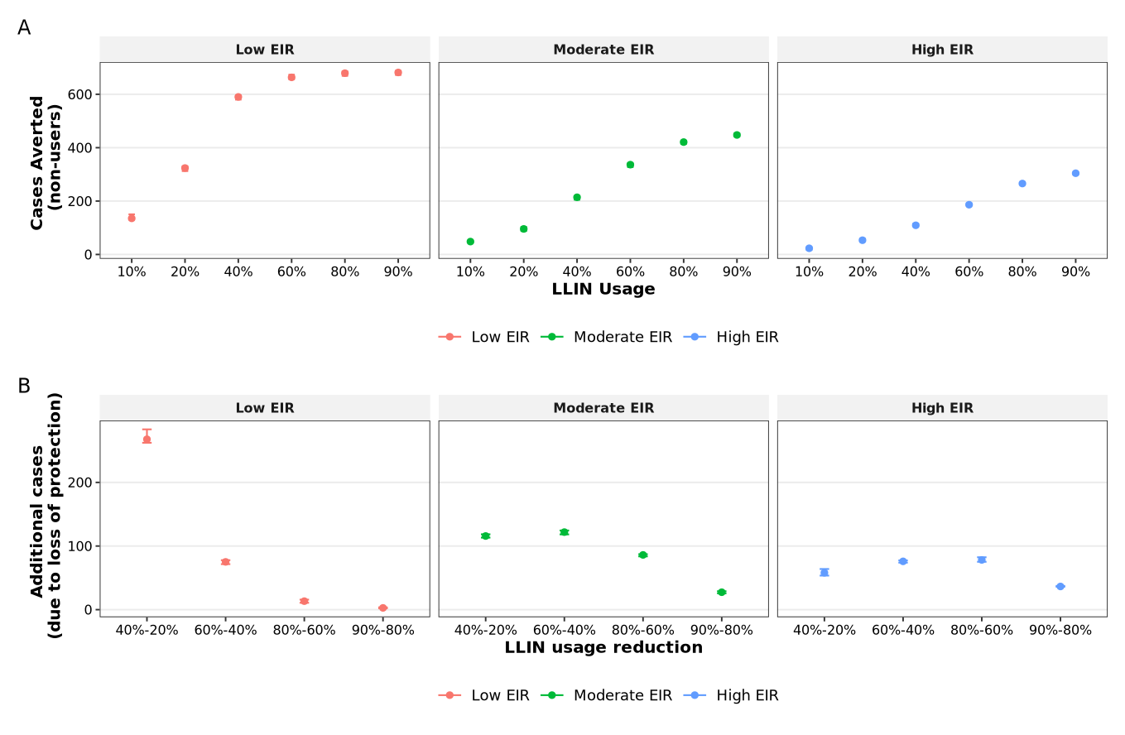
Cases averted – all ages
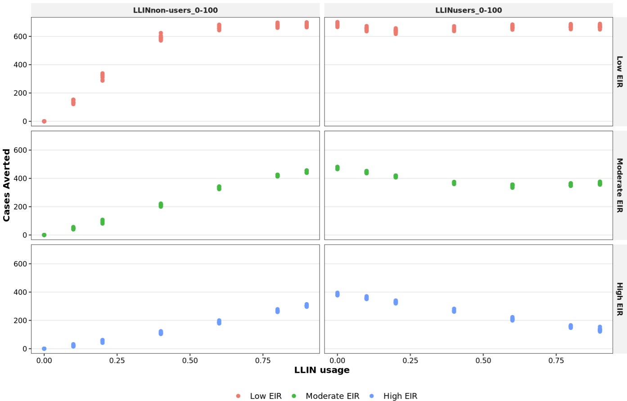
Cases averted – U5
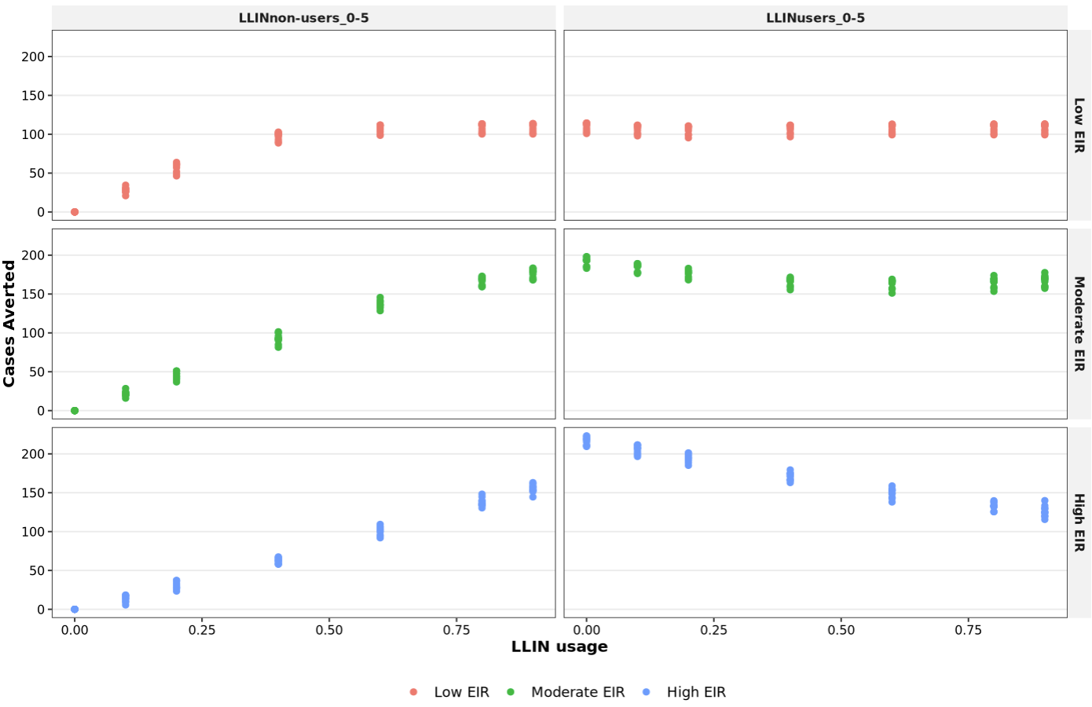

The disparity in infection risk between LLIN users and non-users decreases with increasing usage: 